James Keller – GES408 – Week 6 Lab
- Descriptives → Distribution Plots for all variables. (1 point)
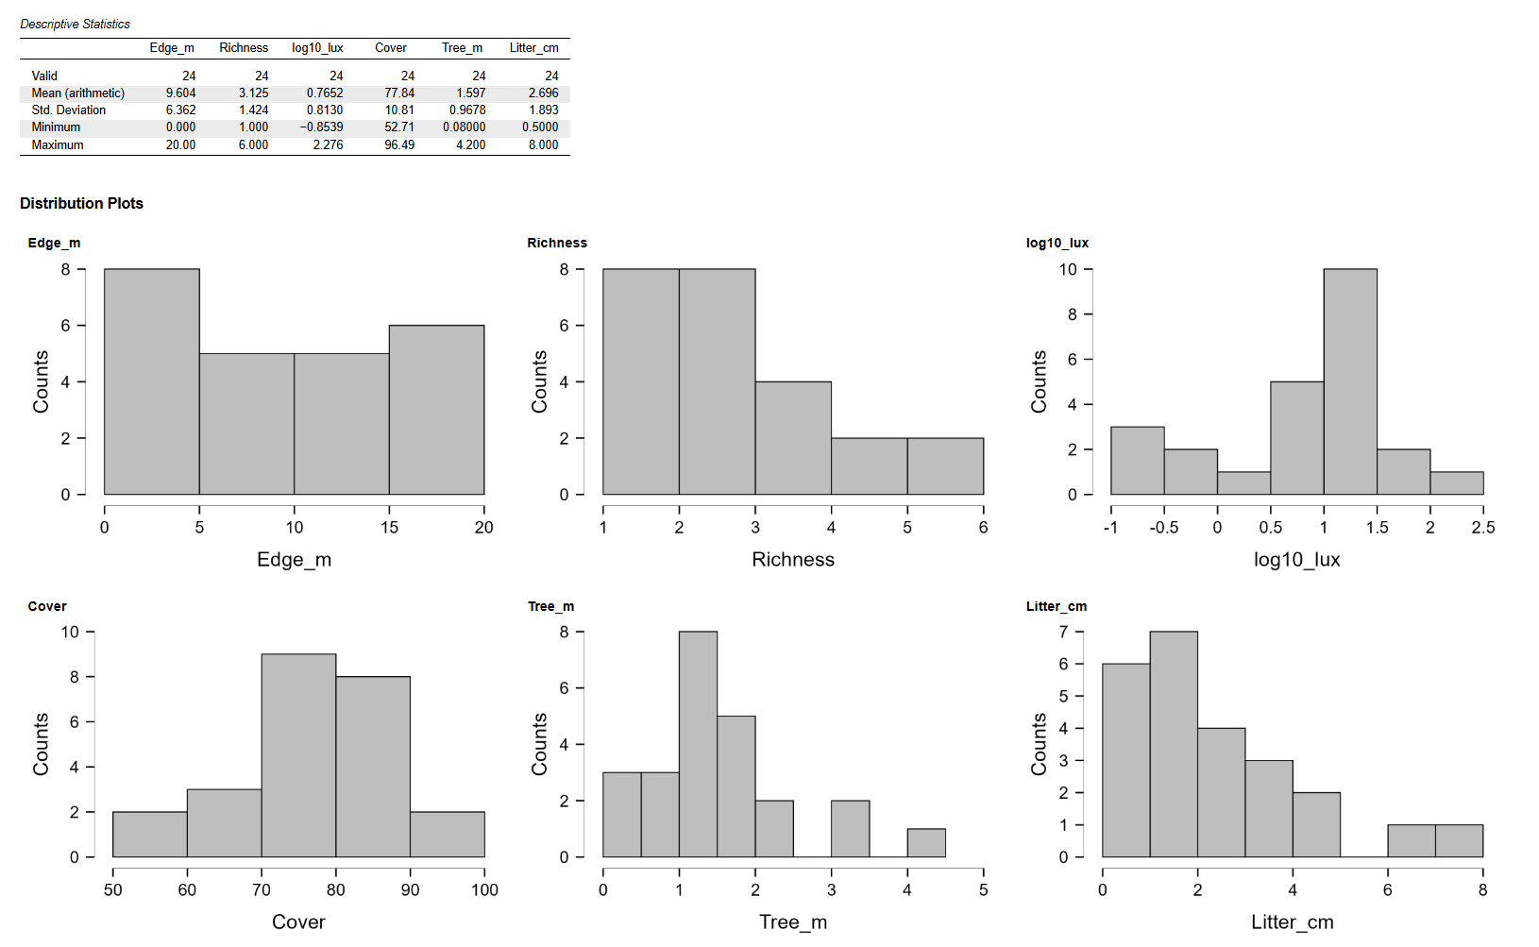
- Comment on what variables you might transform using a log transformation, if any. No need to do the transformation now. (1 point)
I transformed the PAR to get a distribution that is more half-normal. I also would consider a log transform of Edge_m because it has peaks at the extremes.
- Regression → Correlation → Create a correlation matrix (Pearson) by adding all variables. Provide scatter plots and a table. I find that unchecking "Display pairwise" aids legibility. (1 point)
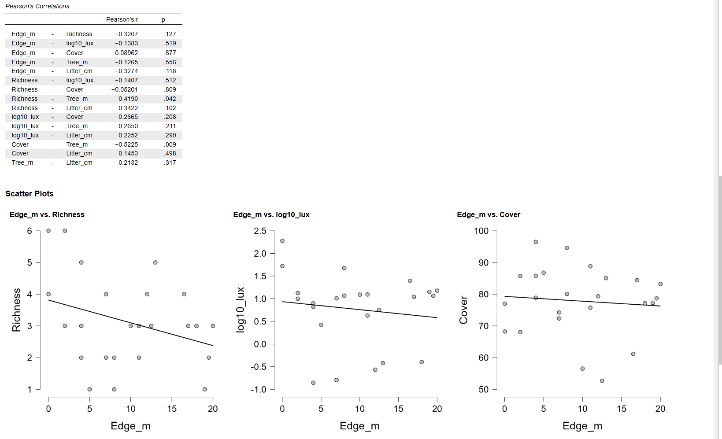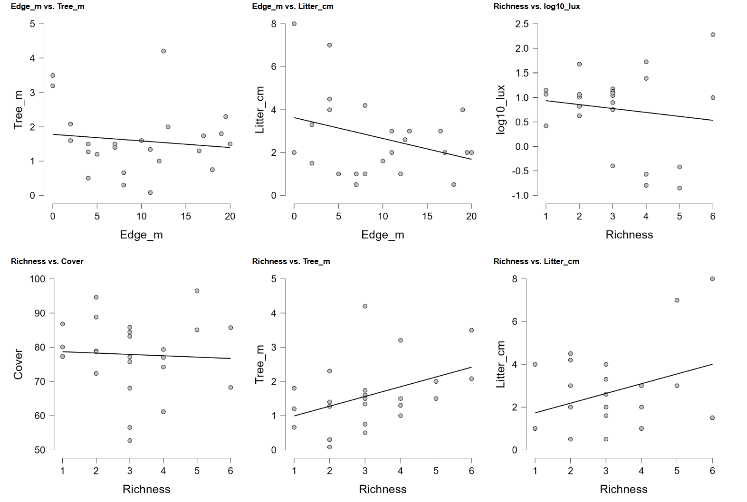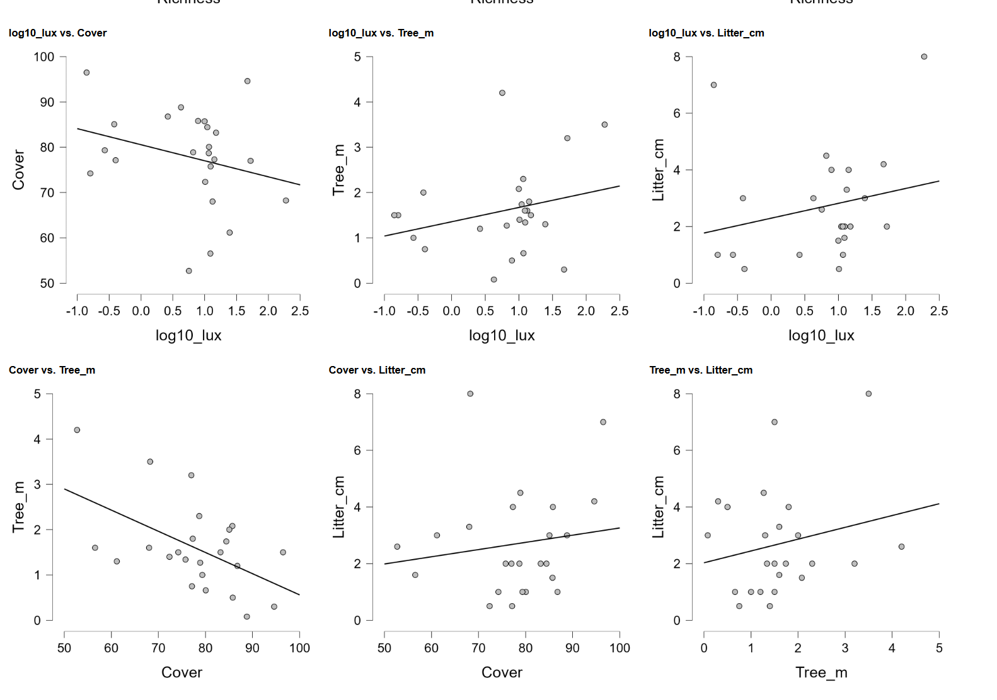
- Do you think there are any variables that are particularly strongly correlated with species richness? If so, which one(s)? (1 point)
I think that distance to the nearest tree in meters is strongly correlated with species richness. This has a p-value of 0.42
- Regression → Linear Regression → Create a model with richness as your dependent variable and log10lux, cover, tree_m, and litter_cm as covariates. Display the model fit, regression equation, coefficient estimates, and tolerance and VIF. Additionally, display the residuals vs predicted plot, and the QQ plot. (2 points)
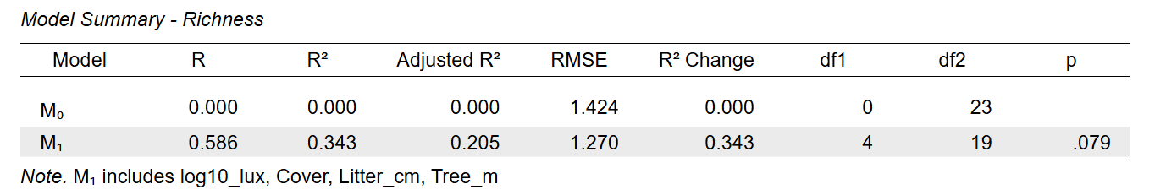
Our regression equation is:
M = 1.137 + -0.5542(log10_lux) + 0.008815(Cover) + 0.2277(Litter_cm) + 0.6963(Tree_m)
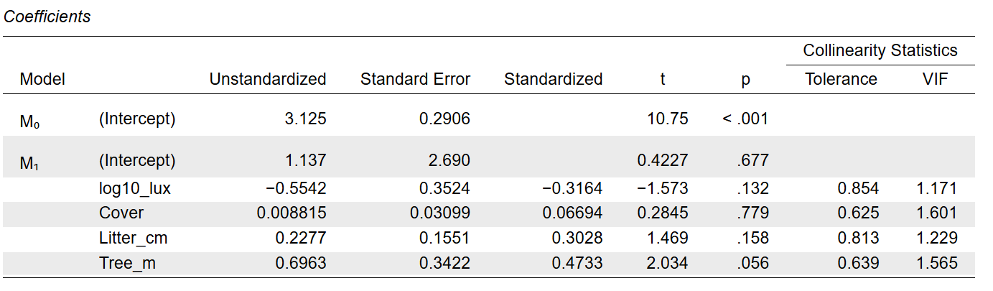

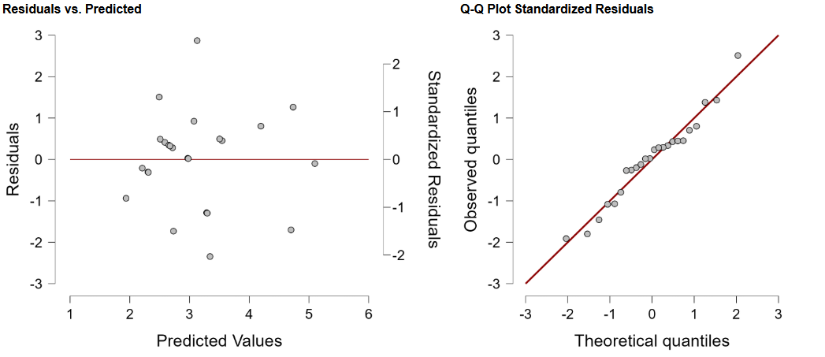
- Are there any variables in this model that are statistically significant? If you had to pick one variable to remove from the model, which one would you choose and why? (1 point)
There are no statistically significant variables in this model. The closest is the distance to the nearest tree in meters with a p-value of 0.056. If I had to remove one variable it would be percent cover which has a p-value of 0.779.
- Is there any evidence of multicollinearity, and how can you tell? (1 point)
There is no evidence of multicollinearity. We can tell this because all the variance inflation factors are relatively low, ranging from 1.1 to 1.6.
- Regression → Linear Regression → Create another model, this time adding in edge_m as a covariate. Display the model fit, regression equation, coefficient estimates, and tolerance and VIF. Additionally, display the residuals vs predicted plot, and the QQ plot. (1 point)
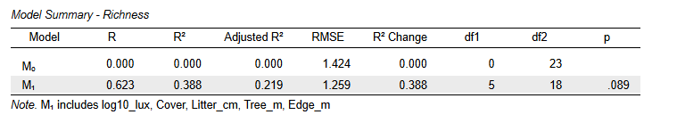
Our regression equation is:
M = 2.156 + -0.5876(log10_lux) + 0.004746(Cover) + 0.1826(Litter_cm) + 0.6563(Tree_m) – 0.05102(Edge_m)
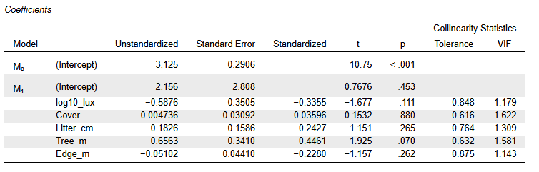
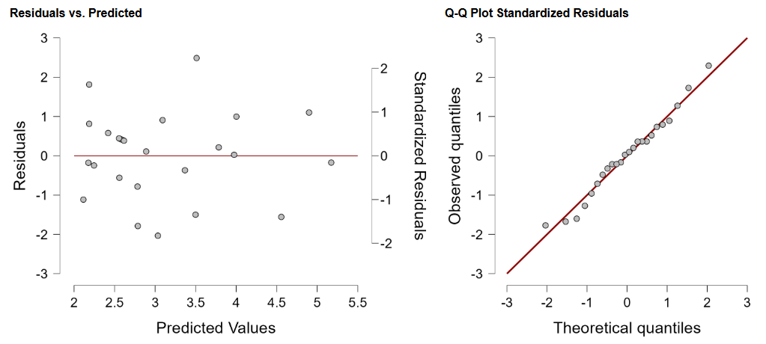

- Compare the R2 and adjusted R2 values between this model and the last one. Which one might be a better model to use? (1 point)
I believe that the second model, which includes distance from the forest edge, would be a better model to use because its R2 and adjusted R2 values are higher.
Non-adjusted: 0.343 -> 0.388
Adjusted: 0.205 -> 0.219
- In looking at your model coefficients, you can see that there are unstandardized and standardized coefficients. The unstandardized ones are those that you can see in your regression equation, and you're able to use them to predict a value for your dependent variable given measurements of all your other variables. Standardized coefficients have no units, and give you information on how many standard deviations a dependent variable will change per standard deviation increase in the covariate. Knowing this, which predictor has the strongest standardized effect? (1 point)
The predictor with the strongest standardized effect is Tree_m because for both scenarios it has the highest standardized coefficient. This means that the dependent variable (species richness) will change the most if the standard deviation of Tree_m increases.
- When looking at your diagnostics and your latest model, if you would have performed a transformation earlier or maybe removed a covariate in your model, try that now and compare it to the model from part 5. If you would not have done these things, reiterate why. (2 points)
I removed % Cover and did a log10 transform on Edge_m. This gave me a model with a higher R2 and adjusted R2 than the previous two. For my log transform of Edge_m, if the original value was 0 I kept the value as 0.
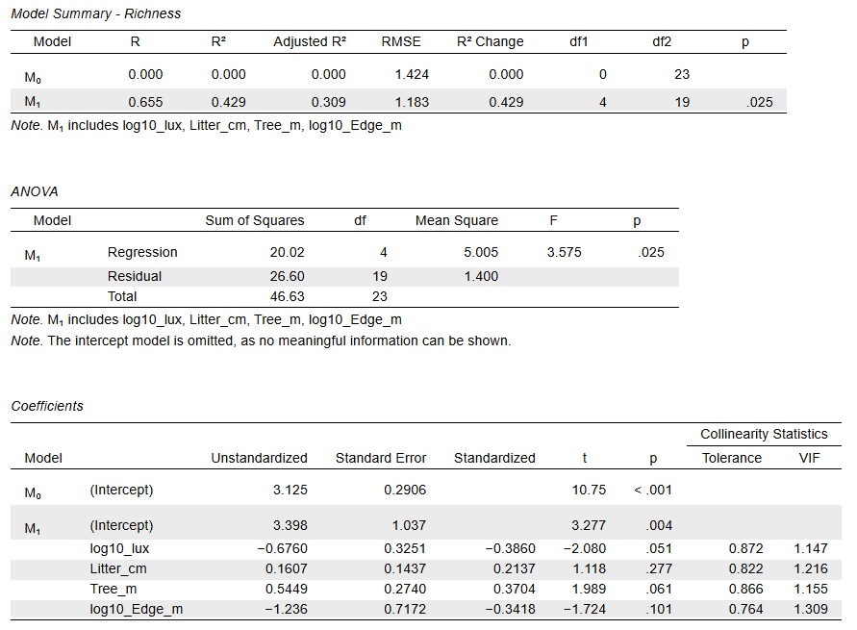
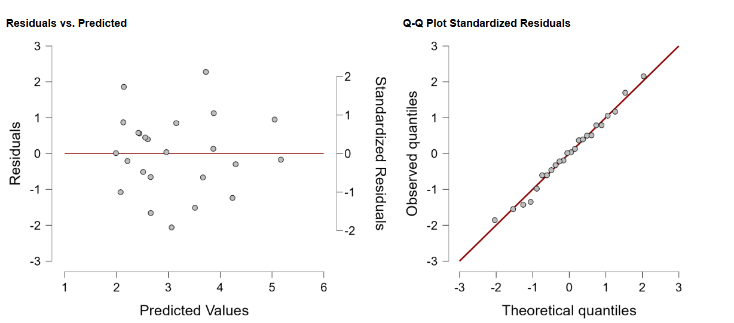
- Lastly, what does a coefficient mean in ecological terms (holding others constant)? You can use an example from your model to illustrate. (1 point)
A coefficient tells us how much a response variable would change if a predictor increases by 1 unit. For example with my second model including Edge_m, for every 1m increase in distance to the nearest tree and all other predictors held constant, species richness is expected to increase by 0.6563.

